Supporting Information

Insight into the Distribution of Pharmaceuticals in Soil-Water-Plant Systems
Yuanbo Li, J. Brett Sallach, Wei Zhang, Stephen A. Boyd, and Hui Li*
Department of Plant, Soil and Microbial Sciences, Michigan State University, East Lansing, MI 48824, USA
* Corresponding Author: Phone: 517-355-0151; e-mail: lihui@msu.edu

Contents

Table S1. Optimized MRM parameters for analysis of pharmaceuticals by LC-MS/MS.
Table S2. Mean extraction efficiency (%) of pharmaceuticals from radish tissues and soil (spiked at 25 ng/g) with the relative standard deviation (%) reported in parenthesis (n = 3).
Table S3. Method detection limits (MDL) of pharmaceuticals in radish tissues, soil and pore water.
Table S4. Pharmaceutical concentration (ng/g) in radish tissues growing in greenhouse at three levels of soil water content. Concentration is expressed as ng/g of dry weight (mean ± standard deviation, n = 3).
Table S5. The detailed data of BCF_{soil} and BCF_{pore water} of radish root uptake of triclosan from five soils.
Table S6. Sorption coefficients (K) of pharmaceuticals was estimated from sorption isotherm.
Figure S1. Comparison of the biomass of dried radish roots and leaves growing at three soil water contents. Error bars represent the standard deviation. MWHC refers to maximum water holding capacity.
Figure S2. The amount of transpired water per radish plant per day growing at three levels of soil water content from day 20 to 34. During this period, radish experienced the most vigorous growth stage. The transpired water was estimated as the difference of water loss between the pots with and without plants.
Figure S3. Bioconcentration factor (BCF) of pharmaceuticals in radish roots on the basis of pharmaceutical concentration in pore water (mL/g) and in bulk soil (g/g). MWHC refers to maximum water holding capacity of soil.
Figure S4. Translocation factor (TF) of pharmaceuticals in radish at day 28 and day 35 growing at three soil water contents. TF is calculated as the ratio of pharmaceutical concentration in leaves to that in roots. MWHC refers to maximum water holding capacity of soil.
Figure S5. Comparison of BCF_{soil} and BCF_{pore water} of triclosan in radish roots from five soils.
Figure S6. Pharmaceutical concentration in bulk soil and pore water as a function of time (days). Error bars represent the standard deviations.
Figure S7. Comparison of the sorption isotherms measured after 48-hour equilibration with the extractable pharmaceutical concentration in soil (C_{s}) and pore water concentration (C_{w}) at the sampling time of 1, 3, 7, 14, 21, 28 and 35 days in the radish-free controls. The data also included the results from the pot experiments sampled at day 28 and 35.

LC-MS/MS Analysis. For the pharmaceuticals analyzed with positive ionization source, the binary mobile phase consisted of phase A water containing 0.3% formic acid and phase B acetonitrile/methanol (65/35, v/v) containing 0.3% formic acid. The flow system was pre-equilibrated with 100% phase A for 2 min, and the gradient program (with respect to phase B) was set as phase B increased to 40% during 0.01–1.0 min, to 70% during 1.0–2.0 min, to 80% during 2.0-3.0 min, phase B increased to 100% during 3.0-3.5 min, and held it until 7.2 min. For the pharmaceuticals analyzed with negative ionization source, mobile phase consisted of phase A 0.005% ammonium hydroxide aqueous solution and phase B acetonitrile/methanol (90/10, v/v). The flow system was pre-equilibrated with 100% phase A for 2 min, and the gradient program (with respect to phase B) was set as from 0.01 to 2.0 min phase B increased to 5%, and from 2.0 to 10.0 min phase B increased to 100% and held it to 12.0 min. The flow rate was 0.35 mL/min, and the sample injection volume was 10 μL. Quantitative analysis was performed using multiple reaction monitoring (MRM) mode, and the optimized parameters are listed in Table S1. The Turbo IonSpray source of the mass spectrometer was operated both in positive and negative mode with ionspray voltage of 5000 V and temperature at 700 °C. Curtain gas pressure was 20 psi, collision gas pressure was 6 psi, and ion source gas pressure was 60 psi.
Quality Assurance and Control. Qualitative and quantitative analysis of pharmaceuticals in samples was based on retention time, MRM ion transitions, and the ratios of the ion abundance. To account for the potential loss of pharmaceuticals, method blank (methanol), matrix blank, matrix spike, and matrix spike duplicate were included in all batch of samples. In this study, external matrix-matched calibration standards were utilized for quantification to correct the potential matrix effects. Matrix recoveries and method detection limits (MDLs) of pharmaceuticals are summarized in Table S2 and S3, respectively. The MDL value was determined by spiking a small amount of studied pharmaceuticals to samples, then extracted and analyzed by the optimized methods. The pharmaceutical concentration with the response of signal-to-noise ratios greater equal to 3 was referred to as the MDL.
Sorption Experiment. Briefly, 1.5 g of soil (dry weight) was placed in a 50-mL glass centrifuge tube, followed by the addition of 30 mL of 0.01 M CaCl₂ solution containing 0.2% NaN₃ (to suppress microbial activity). The soil samples were spiked with 20 μL of mixed solution to achieve nominal concentration of 40, 80, 160, 320, 640, and 1000 ng/mL for each pharmaceutical in the aqueous solution. The soil suspensions were continuously mixed at a rotator at 50 rpm for 48 h at the room temperature (23 ± 2 ºC). Previous experiment showed that the sorption equilibrium was achieved within 48 h for all pharmaceuticals tested. Then, the tubes were centrifuged at 1460 g for 10 min, and 1.0 mL of supernatant was collected. The supernatant was passed through a 0.22 μm PTFE membrane, and an aliquot of 0.5 mL of solution was diluted to 1.0 mL with methanol prior to pharmaceutical analysis using LC-MS/MS. Soil-free controls (0.01 M CaCl₂ solution containing 0.2% NaN₃) with only the spiked pharmaceuticals were also prepared for each initial solution. The soil-sorbed concentration was calculated as the difference between the pharmaceutical concentration in the soil-free controls and the corresponding aqueous pharmaceutical concentration in the presence of soil. The sorption coefficient (K) was calculated from the slope of linear sorption isotherm of pharmaceutical by the tested soil.

Table S1. Optimized MRM parameters for analysis of pharmaceuticals by LC-MS/MS.
Pharmaceuticals | Ionization Mode | Quantitative transition | Qualitative transition
Acetaminophen | positive | 152.0→110.0 | 152.0→93.0
Caffeine |  | 195.0→138.0 | 195.0→110.0
Carbamazepine |  | 237.2→194.0 | 237.2→192.0
Sulfadiazine |  | 251.1→92.2 | 251.1→108.1
Sulfamethoxazole |  | 254.0→108.1 | 254.0→156.2
Lamotrigine |  | 256.0→210.7 | 256.0→165.7
Carbadox |  | 263.0→231.0 | 263.0→159.1
Trimethoprim |  | 291.4→230.4 | 291.4→261.3
Lincomycin |  | 407.2→126.2 | 407.2→359.3
Oxytetracycline |  | 461.3→426.3 | 461.3→283.1
Monensin |  | 693.5→461.4 | 693.5→479.6
Tylosin |  | 916.6→174.3 | 916.6→101.3
Estrone | negative | 269.1→145.0 | 269.1→143.0
17 β-estradiol |  | 271.0→182.9 | 271.0→144.8
Triclosan |  | 286.9→35.0 | 289.0→35.0

Table S2. Mean extraction efficiency (%) of pharmaceuticals from radish tissues and soil (spiked at 25 ng/g) with the relative standard deviation (%) reported in parenthesis (n = 3).
Pharmaceuticals | Leaves | Roots | Soil
Acetaminophen | 78.0 (4.6) | 100.8 (3.2) | 73.9 (5.9)
Caffeine | 74.6 (5.4) | 82.1 (1.6) | 71.3 (7.4)
Carbamazepine | 88.7 (2.1) | 92.4 (5.9) | 95.8 (8.1)
Sulfadiazine | 73.5 (3.5) | 79.1 (3.0) | 82.4 (1.4)
Sulfamethoxazole | 75.7 (6.1) | 80.5 (2.2) | 76.7 (3.8)
Lamotrigine | 56.4 (4.0) | 62.7 (4.6) | 68.3 (2.5)
Carbadox | 80.6 (3.1) | 75.8 (9.3) | 97.0 (6.5)
Trimethoprim | 76.9 (2.6) | 84.3 (6.8) | 111.4 (10.1)
Lincomycin | 83.9 (7.5) | 104.1 (9.7) | 81.4 (5.0)
Oxytetracycline | 50.6 (5.3) | 54.6 (3.8) | 39.8 (4.3)
Monensin | 86.4 (3.6) | 94.8 (10.5) | 92.6 (6.2)
Tylosin | 60.6 (6.7) | 68.7 (2.1) | 70.3 (5.8)
Estrone | 74.9 (7.7) | 80.0 (8.5) | 91.8 (11.3)
17 β-estradiol | 73.2 (6.2) | 86.1 (9.3) | 108.4 (12.4)
Triclosan | 85.6 (2.9) | 98.4 (7.1) | 90.3 (3.7)

Table S3. Method detection limits (MDL)ª of pharmaceuticals in radish tissues, soil and pore water.

Pharmaceuticals | Leaves (ng/g) | Roots (ng/g) | Soil (ng/g) | Pore water (ng/mL)
Acetaminophen | 3.4 | 3.1 | 1.5 | 0.5
Caffeine | 1.8 | 1.6 | 0.8 | 0.6
Carbamazepine | 0.7 | 0.7 | 0.7 | 0.5
Sulfadiazine | 2.7 | 2.6 | 2.1 | 0.5
Sulfamethoxazole | 3.4 | 3.5 | 3.0 | 0.5
Lamotrigine | 4.2 | 4.1 | 3.5 | 0.5
Carbadox | 6.5 | 6.3 | 5.2 | 0.5
Trimethoprim | 5.1 | 4.8 | 3.7 | 0.5
Lincomycin | 2.4 | 2.2 | 1.8 | 0.7
Oxytetracycline | 3.1 | 3.0 | 3.3 | 2.0
Monensin | 0.8 | 0.8 | 0.7 | 0.5
Tylosin | 2.0 | 2.1 | 2.0 | 0.8
Estrone | 2.2 | 2.0 | 1.9 | 1.2
17 β-estradiol | 2.6 | 2.5 | 2.2 | 1.2
Triclosan | 4.1 | 3.8 | 2.6 | 1.0
ª signal-to-noise ratio = 3

Table S4. Pharmaceutical concentration (ng/g) in radish tissues growing in greenhouse at three levels of soil water content. Concentration is expressed as ng/g of dry weight (mean ± standard deviation, n = 3).
Pharmaceuticals | Soil water content | Day 28 (premature) |  | Day 35 (mature)
 |  | Roots | Leaves | Roots | Leaves
Acetaminophen | 75% MWHC | 128 ± 14.8 | 32.6 ± 5.6 | 90.1 ± 18.1 | 30.5 ± 3.9
 | 60% MWHC | 149 ± 21.0 | 50.1 ± 13.9 | 106 ± 14.6 | 46.9 ± 5.8
 | 45% MWHC | 139 ± 8.9 | 40.8 ± 17.7 | 116 ± 16.6 | 40.5 ± 14.8
Caffeine | 75% MWHC | 34.6 ± 15.1 | 1343 ± 253 | 13.5 ± 8.1 | 481 ± 53.0
 | 60% MWHC | 36.3 ± 20.1 | 1304 ± 154 | 17.9 ± 6.1 | 567 ± 114
 | 45% MWHC | 90.2 ± 38.4 | 2685 ± 376 | 32.0 ± 11.0 | 1308 ± 262
Carbamazepine | 75% MWHC | 1619 ± 56.5 | 12770 ± 286 | 1772 ± 126 | 14080 ± 688
 | 60% MWHC | 1674 ± 203 | 12487 ± 293 | 1600 ± 142 | 12510 ± 167
 | 45% MWHC | 1774 ± 70.1 | 12931 ± 309 | 1683 ± 135 | 13537 ± 746
Sulfadiazine | 75% MWHC | 11.9 ± 2.3 | 26.1 ± 4.7 | 8.0 ± 3.7 | 24.6 ± 6.0
 | 60% MWHC | 7.0 ± 1.0 | 20.4 ± 3.7 | 7.5 ± 6.0 | 19.6 ± 5.2
 | 45% MWHC | 10.7 ± 2.6 | 23.1 ± 1.1 | 8.4 ± 1.8 | 22.8 ± 2.3
Sulfamethoxazole | 75% MWHC | 20.8 ± 0.6 | 45.1 ± 13.6 | 14.3 ± 10.9 | 30.8 ± 6.5
 | 60% MWHC | 13.0 ± 2.0 | 32.1 ± 3.7 | 8.9 ± 0.4 | 25.3 ± 12.5
 | 45% MWHC | 14.4 ± 1.7 | 35.6 ± 1.3 | 12.9 ± 2.1 | 28.5 ± 7.1
Lamotrigine | 75% MWHC | 350 ± 17.9 | 675 ± 58.8 | 587 ± 105 | 1351 ± 179
 | 60% MWHC | 367 ± 27.4 | 797 ± 63.4 | 633 ± 262 | 1107 ± 248
 | 45% MWHC | 499 ± 96.8 | 834 ± 60.2 | 557 ± 61.3 | 1029 ± 148
Carbadox | 75% MWHC | 35.0 ± 22.3 | 63.6 ± 6.1 | 54.0 ± 8.6 | 88.8 ± 22.7
 | 60% MWHC | 39.6 ± 13.2 | 77.0 ± 11.3 | 39.2 ± 17.3 | 83.2 ± 11.5
 | 45% MWHC | 51.5 ± 6.5 | 81.8 ± 34.4 | 56.5 ± 2.3 | 104.8 ± 31.0
Trimethoprim | 75% MWHC | 76.4 ± 1.7 | 462 ± 37.3 | 111 ± 25.6 | 563 ± 55.5
 | 60% MWHC | 95.0 ± 9.5 | 559 ± 45.4 | 106 ± 2.2 | 494 ± 33.5
 | 45% MWHC | 86.6 ± 9.7 | 513 ± 32.3 | 127 ± 9.9 | 598 ± 110
Lincomycin | 75% MWHC | 4.7 ± 0.2 | 41.3 ± 9.6 | 3.1 ± 0.7 | 29.6 ± 3.2
 | 60% MWHC | 3.3 ± 0.9 | 36.6 ± 7.4 | 2.9 ± 0.5 | 32.5 ± 4.6
 | 45% MWHC | 3.2 ± 0.2 | 28.5 ± 3.8 | 2.4 ± 0.3 | 25.3 ± 7.0
Oxytetracycline | 75% MWHC | 19.1 ± 1.1 | 9.3 ± 2.7 | 19.9 ± 4.3 | 13.0 ± 2.2
 | 60% MWHC | 16.9 ± 0.7 | 11.5 ± 4.3 | 23.9 ± 7.8 | 11.9 ± 3.1
 | 45% MWHC | 19.0 ± 1.1 | 10.7 ± 2.4 | 26.2 ± 3.1 | 16.2 ± 5.0
Monensin | 75% MWHC | 5.0 ± 0.3 | N.D.ª | 5.2 ± 2.3 | N.D.
 | 60% MWHC | 4.2 ± 0.2 | N.D. | 4.5 ± 2.5 | N.D.
 | 45% MWHC | 6.1 ± 1.0 | N.D. | 3.7 ± 1.4 | N.D.
Tylosin | 75% MWHC | 9.6 ± 1.2 | 3.8 ± 0.6 | 7.7 ± 2.4 | 3.3 ± 0.3
 | 60% MWHC | 7.8 ± 1.0 | 4.1 ± 0.2 | 6.0 ± 0.6 | 2.1 ± 0.2
 | 45% MWHC | 10.0 ± 3.0 | 3.9 ± 0.5 | 8.2 ± 2.0 | 4.1 ± 1.0
Estrone | 75% MWHC | 8.4 ± 0.2 | 12.3 ± 0.7 | 3.0 ± 0.2 | 3.9 ± 1.2
 | 60% MWHC | 5.5 ± 1.0 | 5.6 ± 0.8 | 2.4 ± 0.3 | 3.6 ± 0.6
 | 45% MWHC | 9.2 ± 6.2 | 10.2 ± 2.2 | 3.6 ± 3.1 | 3.7 ± 0.4
17 β-estradiol | 75% MWHC | N.D. | N.D. | N.D. | N.D.
 | 60% MWHC | N.D. | N.D. | N.D. | N.D.
 | 45% MWHC | N.D. | N.D. | N.D. | N.D.
Triclosan | 75% MWHC | 56.6 ± 7.3 | 49.1 ± 8.5 | 86.4 ± 7.0 | 40.6 ± 11.0
 | 60% MWHC | 64.5 ± 10.1 | 53.0 ± 14.7 | 90.6 ± 19.7 | 38.6 ± 8.7
 | 45% MWHC | 89.9 ± 38.2 | 63.8 ± 17.8 | 151 ± 14.1 | 60.2 ± 4.5
N.D.: not detected.

Table S5. The detailed data of BCF_{soil} and BCF_{pore water} of radish root uptake of triclosan from five soils.
Soil | OC (%) | K_{d} (L/kg) | BCF_{soil} | BCF_{pore water} | Exposure (day) | Reference
This study | 1.6 | ─ | 0.13 ± 0.03 | 43.8 ± 5.24 ª | 35 | This study
A | 0.4 | 35 | 2.10 ± 0.10 | 73.5 | 35 | (Fu et al., 2016a; Fu et al., 2016b)
B | 1.2 | 137 | 0.30 ± 0.10 | 41.1 | 35 | (Fu et al., 2016a; Fu et al., 2016b)
C | 2.5 | 311 | 0.25 ± 0.17 | 77.8 | 35 | (Fu et al., 2016a; Fu et al., 2016b)
D | 3.5 | 731 | 0.12 ± 0.04 | 87.7 | 35 | (Fu et al., 2016a; Fu et al., 2016b)
ª Average the data at day 28 and 35.

Table S6. Sorption coefficient (K) of pharmaceuticals by soil was estimated from sorption isotherm.
Pharmaceuticals | K (mL/g) | R² (n = 12)
Acetaminophen | 1.8 | 0.996
Caffeine | 7.8 | 0.975
Carbamazepine | 5.4 | 0.988
Sulfadiazine | 0.9 | 0.967
Sulfamethoxazole | 0.9 | 0.958
Lamotrigine | 4.6 | 0.990
Carbadox | 26.1 | 0.990
Trimethoprim | 19.8 | 0.991
Lincomycin | 0.9 | 0.883
Oxytetracycline | 129.3 | 0.983
Monensin | 2.7 | 0.909
Tylosin | 9.8 | 0.987
Estrone | 48.9 | 0.965
17 β-estradiol | 38.5 | 0.950
Triclosan | 270.3 | 0.987

Figure S1. Comparison of the biomass of dried radish roots and leaves growing in the pharmaceutical-spiked soil at three soil water contents. Error bars represent the standard deviation (n = 3). MWHC refers to maximum water holding capacity.

Figure S2. The amount of transpired water per radish plant per day growing at three levels of soil water content from day 20 to 34. During this period, radish experienced the most vigorous growth stage. The transpired water was estimated as the difference of water loss between the pots with and without plants.

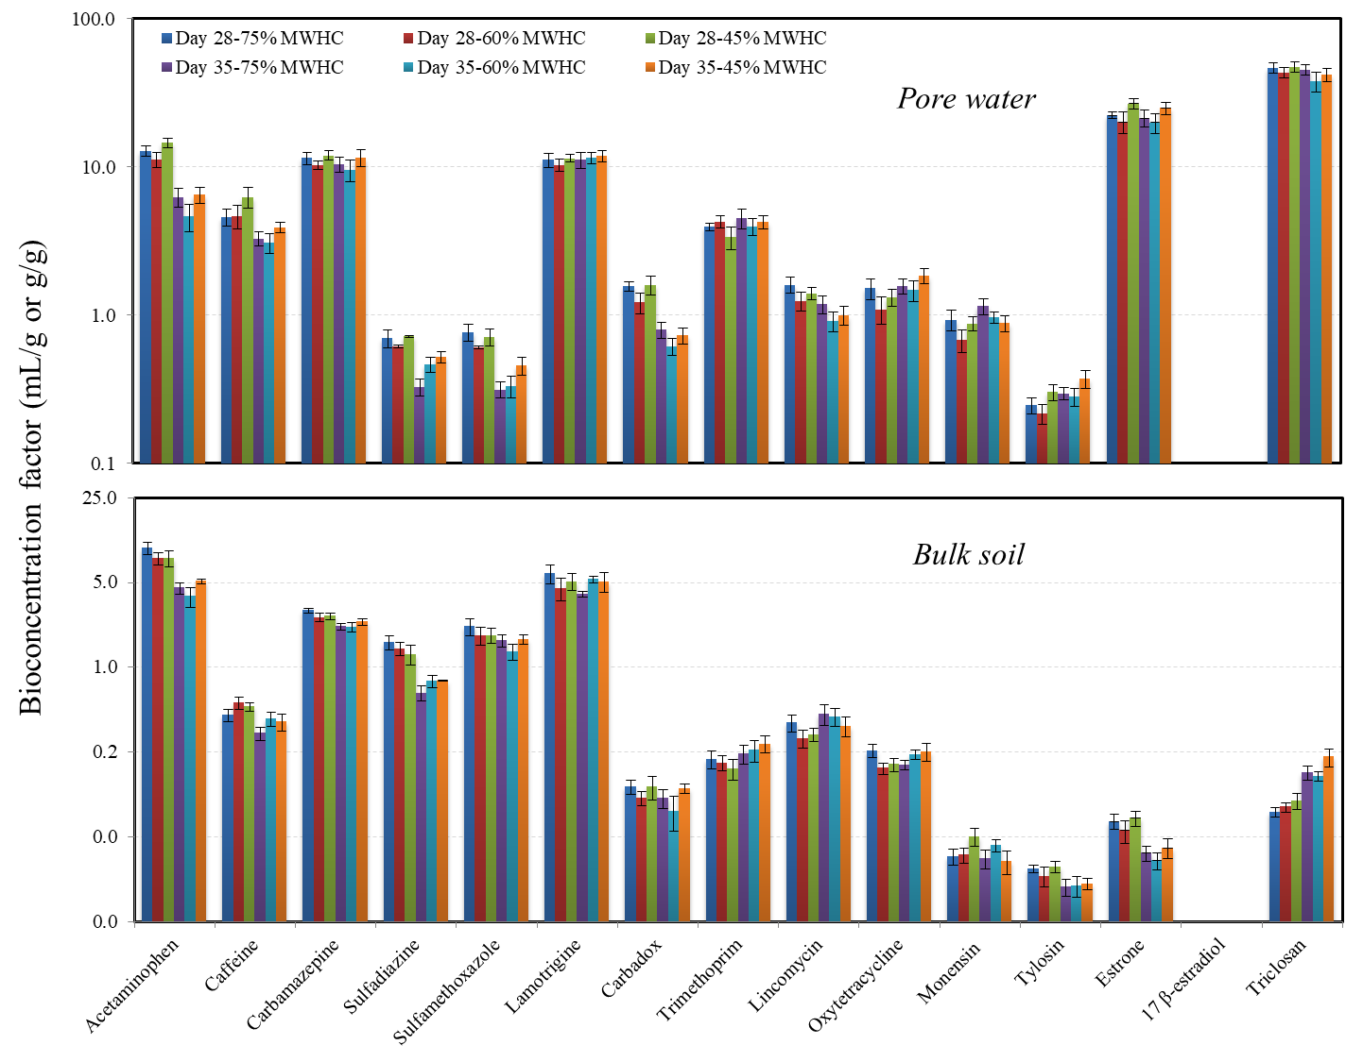
Figure S3. Bioconcentration factor of pharmaceuticals in radish roots on the basis of pharmaceutical concentration in pore water (mL/g) and in bulk soil (g/g). MWHC refers to maximum water holding capacity of soil.

Figure S4. Translocation factor (TF) of pharmaceuticals in radish at day 28 and day 35 growing at three soil water contents. TF is calculated as the ratio of pharmaceutical concentration in leaves to that in roots. MWHC refers to maximum water holding capacity of soil.

Figure S5. Comparison of BCF_{soil} and BCF_{pore water} of radish root uptake of triclosan from five soils. Data of soil A-D are from the previous studies (Fu et al., 2016a; Fu et al., 2016b).

Figure S6. Pharmaceutical concentration in bulk soil and pore water as a function of time (days) in the radish-free soil controls as a function of time (days). The triplicates samples were prepared at three soil water contents. No significant difference was observed for the samples at different soil water contents. Error bars represent the standard deviation (one sample per pot, n = 9).

Figure S7. Comparison of the sorption isotherm of pharmaceuticals measured after 48-hour equilibration with the extractable pharmaceutical concentration in soil (C_{s}) and pore water concentration (C_{w}) at the sampling time of 1, 3, 7, 14, 21, 28 and 35 days in the radish-free controls. The data also included the results from the pot experiments with radish sampled at day 28 and 35.

References

Fu, Q., Sanganyado, E., Ye, Q., Gan, J., 2016a. Meta-analysis of biosolid effects on persistence of triclosan and triclocarban in soil. Environ. Pollut. 210, 137-144.
Fu, Q., Wu, X., Ye, Q., Ernst, F., Gan, J., 2016b. Biosolids inhibit bioavailability and plant uptake of triclosan and triclocarban. Water Res. 102, 117-124.

